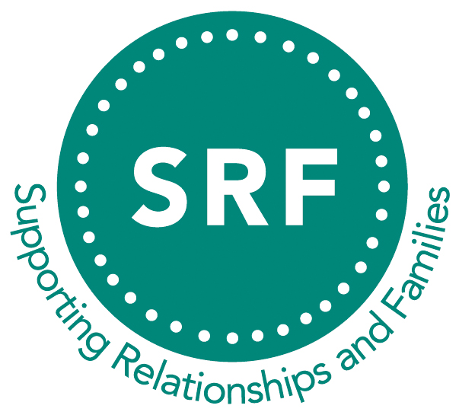

Supporting Relationships and Families
email: serefo.info@gmail.com
www.serefo.org.uk

M E M B E R S H I P A P P L I C A T I O N
(Please complete form in BLOCK CAPITAL LETTERS)

Title: Mr/Mrs/Ms/Dr/Other (please circle where appropriate)
Name: ___________________________________________________________________
Address: _____________________________________________________________________
______________________________________________________________________________
_____________________________________________________________________________
Telephone no: ______________________________ Mobile: _________________________
Email: ______________________________________________________________________
Benefits to SRF members:
- Attendance and voting rights at SRF’s Annual General Meeting
- Reduced fees at our annual conference and seminars
- Access to materials
- Networking opportunities
- Self-development opportunities
- CPD opportunities – seminars/workshops
- Free copies of SRF newsletters
How to Pay:

- Payment can be made through PayPal on www.serefo.org.uk

Date: _________________________________

Please email this form to serefo.info@gmail.com Thank you.

